Start of Mile Relay (start of 1st leg)
Mile and Mile relay course

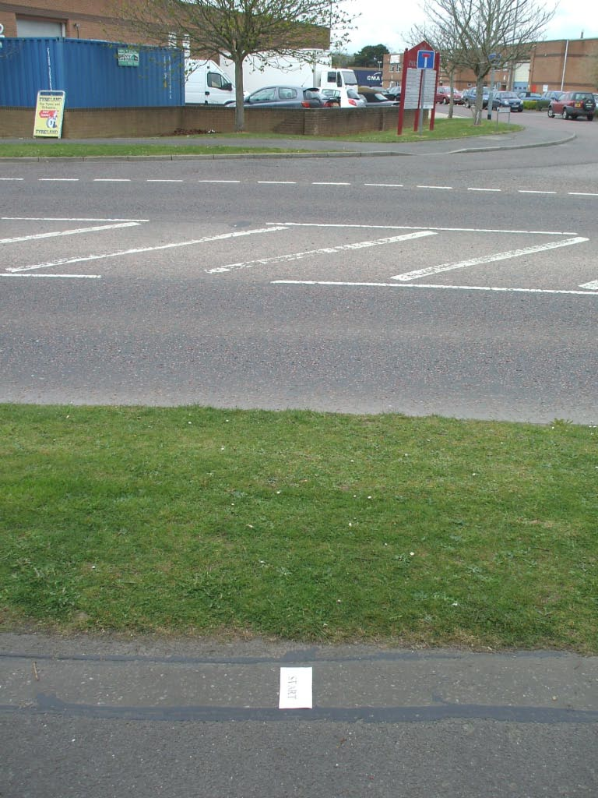

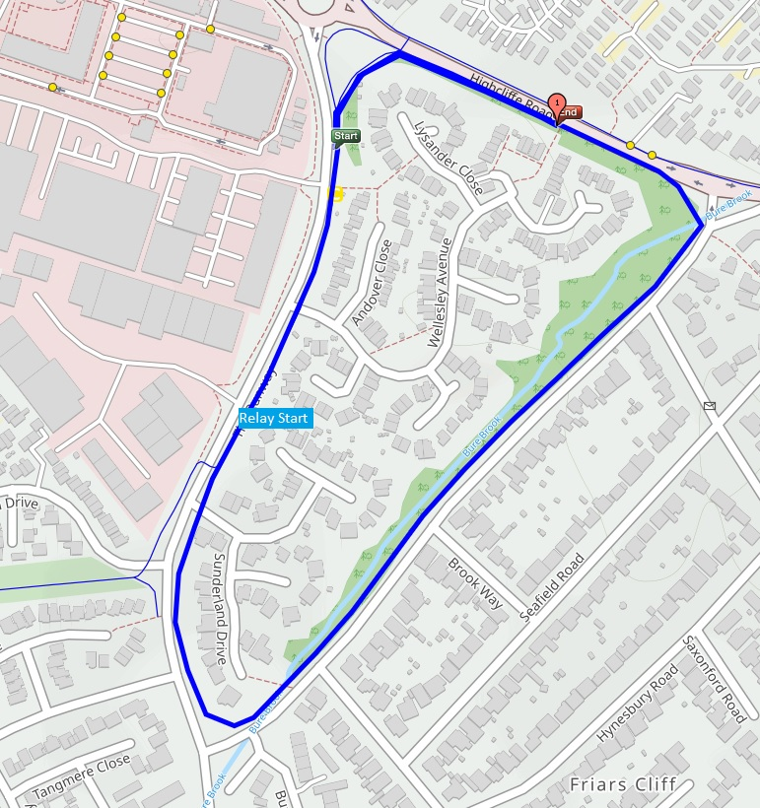
Mile Relay handover (and normal mile start)
Finish of Mile Relay (and normal mile finish)

