This 5k run is a slight variation on the summer monthly run.

<http://www.gmap-pedometer.com/?r=7761443>

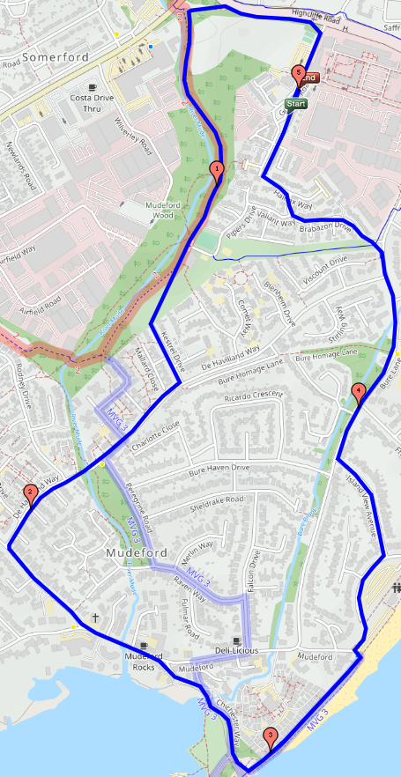

Detailed description:

1. Start at the usual lamp-post on Grange Road.
2. Follow the 'normal' direction, i.e. head north to the dual-carriageway end of Grange Rd and turn left as for the summer route.
3. Follow the monthly run but on the way back, at about 4.5km, short-cut through Brabazon Drive to get to the 'closed' end of Grange Rd.
4. Run north on Grange Rd and the finish line is in line with south wall of the ECSSC (the first wall you get to).
5. You are advised to stay on the right-hand side of Grange Rd as crossing the road is unnecessary.