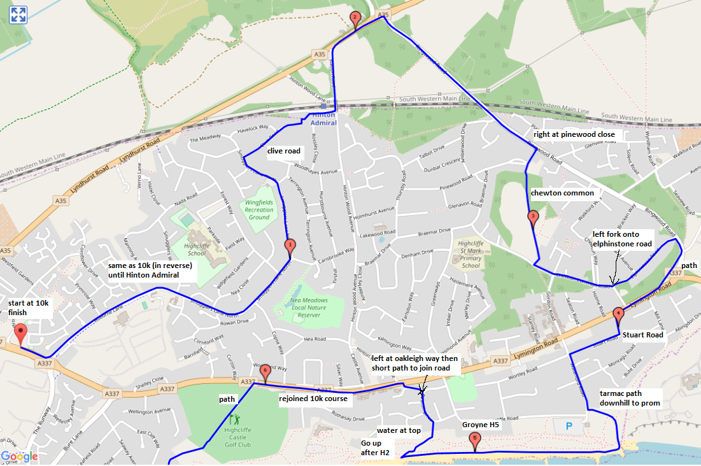
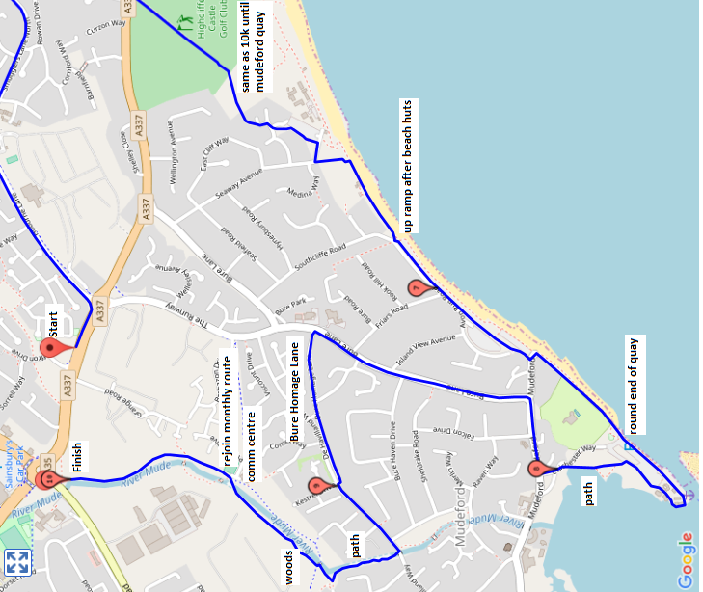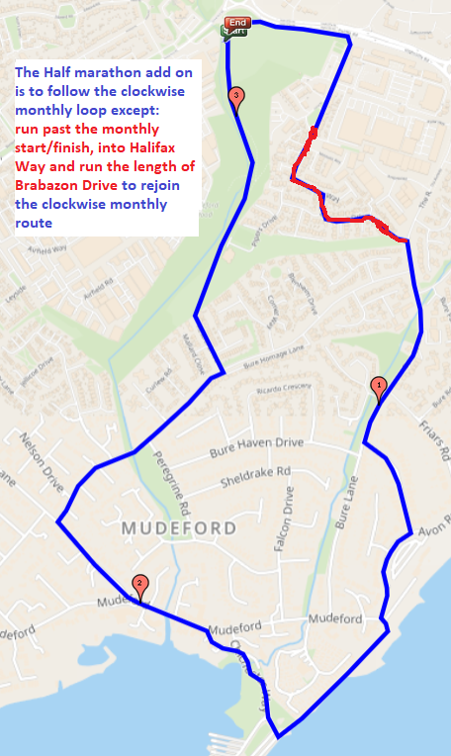
Mile Approximate Position
0 (START)
1 Junction of Smugglers Lane and Forest Way
2 About 50 yards short of the junction of Hinton Wood Road with the A35.
3 About 50 yards or so onto Chewton Common
4 About 50 yards before the entrance to Stuart Road, on Lymington Road
5 About Groyne H4 along the beach, before Mt Smith
6 About 100 yards after entrance to Highcliffe Castle, on Lymington Road
7 About 50 yards after the top of the ramp, towards the sunken car park
8 Just before the entrance (less than 50 yards before Mudeford Lane) to the Mudeford Quay car park
9 At the end of Bure Homage Lane, where it meets De Haviland Way
10 Footpath by brook, by the gate-in-the-fence
11 Half way between Friars Road and Island View Avenue
12 By the Church opposite the Avonmouth Hotel
13 (Approx) The big Oak Tree on the footpath at the back of the cricket pitch.
13.1 Just after the gate in the fence on the footpath behind the cricket pitch (END)

Start by the bus stop in Lymington Road, on housing-side of road, and head towards Highcliffe. At roundabout, turn left into Hoburne Lane. Go up hill, then along for approximately ¼ mile. Turn left into Smugglers Lane North.
After approximately ¼ mile in Smugglers Lane North, there is a short, downhill stretch. At the bottom of this, turn right into Clive Road. At the end of Clive Road, follow the footpath through to Hinton Admiral railway station.
At the far-end of the station, turn left over the railway bridge. Follow road to A35, then turn right, and go past Cat and Fiddle. Take next right-hand turn into Ringwood Road, and follow road down to just past Amberwood pub.
After Amberwood, take first turning on right into Pinewood Close, but then cross to left-hand footpath. The road then turns right (into Pinewood Road), but there is a short cul-de-sac straight ahead. Enter cul-de-sac, find footpath.
Follow footpath across Chewton Common, turning left when you get to Chewton Common Road. Follow Chewton Common Road, turn left into Elphinstone Road, right into Ringwood Road, then right at roundabout into Lymington Road.
Cross Lymington Road, take second left into Stuart Road, and then, at the end, turn left into Waterford Road. When you get near to the car park on the corner, turn left and go down wide tarmac path to sea front.
At sea front, run towards Highcliffe Castle, looking for old Second World War concrete pillbox (near Groyne H2). Just after pillbox, turn right so that you are running up the cliff but back towards Highcliffe. Follow footpath to top of cliff, then between blocks of flats to Beacon Road. Turn left.
Take third turning on left (Oakleigh Way), go to grass area on right-hand side, then across grass to Lymington Road, next to Hinton Oak pub. Turn left. You are now heading towards Christchurch.
At Golf Course, turn left onto footpath. At far end of footpath, cross first road onto another footpath which takes you towards Steamer Point. At next road, turn right, and follow road to where IT turns right, but YOU turn left, past gate, down to beach.
Turn right, go along sea front, up ramp, past sunken car park, back to sea front, then along to harbour entrance (aptly named The Run), run round the edge of the quay, clockwise round houses, then, for the moment, back towards castle, but keeping car park on your right, and using the 'exit' road from the harbour entrance-end of the car park. Follow the footpath that goes off to the left, across to the bridge with the white parapets (which you may remember crossing on the Monthly Race course). Cross the bridge, take right-hand fork in road, then turn right into Mudeford Lane (stay on right-hand side footpath). This will take you down to Bure Lane near the entrance to the Avon Beach car park.
Turn left into Bure Lane (stay on right-hand side footpath until after Island View Avenue), then cross Bure Lane, and turn left up Bure Homage Lane (the old road/track on the left which is just before Bure Lane gets to the Sandpiper pub).
Follow Bure Homage Lane through to De Havilland Way, then along De Havilland Way to the Yellow Brick Road (gravel footpath which is just after Curlew Road). Turn right onto Yellow Brick Road, follow path through woods to Mudeford Wood Community Centre, then along path behind our cricket field to the 10 mile finish by the gate in the fence (gate hidden by holly bush).
Continue to the end of the path (by Somerford Roundabout), then turn right towards Grange Road. Turn right into Grange Road, and cross onto the left hand side of the road when you can. Continue to the end of Grange Road, turn left into Halifax Way. Keep with Halifax Way, Turn right into Brabazon Drive, then follow Brabazon Drive until it meets the Runway. Turn right into the Runway.
Continue down the Runway until you meet Island View Avenue, turn left and continue to the end (the sunken car park). Turn right and skirt the sunken car park, keeping the car park to your left. At the end of the car park follow the path to your right, down a ramp. At the bottom, turn left across the entrance to Avon Beach car park then turn right along the prom. in front of a big wall.
At the end of this prom, turn right after the children's playground, don't go too far into the car park. Follow the road across the small bridge, take the left fork into Chichester Way. Continue on this short road until it meets Mudeford, turn left.
Cross Mudeford when convenient, and then turn right opposite the Avonmouth Hotel into Mudeford Lane. Continue in this road for about 200 metres, turn right into de Havilland Way. At some convenient point cross over on to the left hand side of the road.
Continue along de Havilland Way, turn left into Kestrel Drive and continue in this road until it ends. Go through the gate into the playing field, and head towards the Community Centre and the half marathon finish will be just after the 10 mile point.
These instructions were last updated Feb 2024

