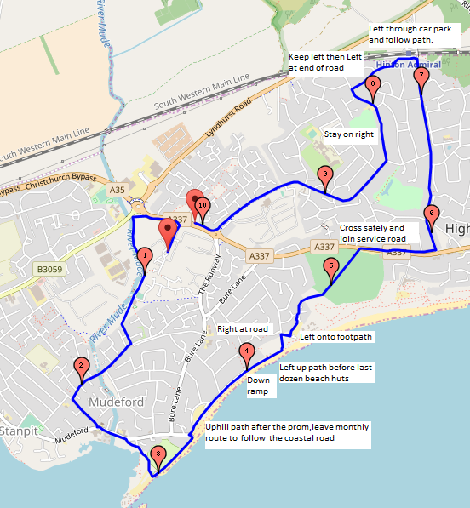
Club 10k route - Zoomable map: https://www.gmap-pedometer.com/?r=7020883
Follow the normal Monthly route for approximately 3.3km (i.e. past Avon Beach to top of slope) then follow instructions on the map to get to 6km in Hinton Wood Avenue, turn left through Hinton Admiral Station finishing with Clive Road, Smugglers Lane North, Hoburne Lane and Highcliffe Road

START | Lamp post in lay-by on Grange Road (Site Side).
The 10K course starts at the same start point as the monthly race - the lamp post in the lay-by in Grange Road. For the first two miles the race follows the monthly race course - along Grange Road, turn left at end; follow pavement; turn left through gate (over bridge) on to footpath along back of cricket pitch.
½ Mile | Footpath on left hand side of track at back of cricket pitch, 6 yards past big tree on right.
Follow footpath to community centre and then cross football pitch; exit through gate to Kestrel Drive; at the end of Kestrel Drive turn right on to De Havilland Way.
1 Mile | 5 ft past water post (WHWC), 19 yards past the post box (De Havilland Way).
At the end of De Havilland Way turn left on to Mudeford Lane.
1½ Mile | Middle of White Garage Doors on right 17 yards past the bus stop on the right hand side.
At the Avonmouth Hotel turn left on to Mudeford Road (cross when convenient); take the first right and follow road to Mudeford Quay; turn left when you reach the quay and follow the sea wall.
2 Mile | 11 yards before the middle of the doors in the wall on the promenade.
At the end of the sea wall turn left before Avon Beach car park and follow the footpath to the right up the hill immediately after the car park entrance. Keep right along the footpath until you get to the main ramp down to the beach huts, then along the front of the beach huts, past the cafe to the gap in the beach huts.
2½ Mile | Outside Beach Hut 17.
Turn left and run up the tarmac path to the gate. Turn right at the gate and follow the road to the rubbish bin and car park sign on the left. Do not cut across the grass. Turn left on to the footpath and follow the footpath up to the golf course.
3 Mile | 6th post (wire fence) on the left side of path, 33 yards from the start of the golf course.
Cross the golf course and turn right towards Highcliffe, crossing over Lymington Road as soon as convenient. Go left into the little side road past the bus stop and run along this until you reach Castle Avenue.
3½ Mile | 17 yards before the brown Highcliffe Castle sign on lamp post on the right hand side.
Turn left and follow this road, which becomes Hinton Wood Avenue.
4 Mile | Outside brown gates (no. 44) opposite Braemar Drive, 65 yards before the post box.
When you reach Station Road by Hinton Admiral Station do not cross the bridge, but turn left down to the station.
4½ Mile | 4½ yards before first telegraph post in Station Rd.
Keep to the left hand side and follow the footpath which eventually becomes Clive Road. At the end of the road turn left on to Smugglers Lane North.
5 Mile | Middle of gate of no. 103.
Keep on this road, which becomes Hoburne Lane.
5½ Mile | Middle of T-junction of Rowan Drive and Smugglers Lane North.
Follow Hoburne Lane down to the roundabout at the far end of the site.
6 Mile | Lamp post with 40 mph sign, 12 yards before mounted post box.
Turn right, keeping on the footpath. Stay on that side of the road, the Finish Line is just past the roundabout road sign.
Finish (6.21Miles/10k) | Tree before two large pine trees on the right of Highcliffe Rd 10 yards past the large traffic sign (for roundabout) and 28 yards before bus stop

