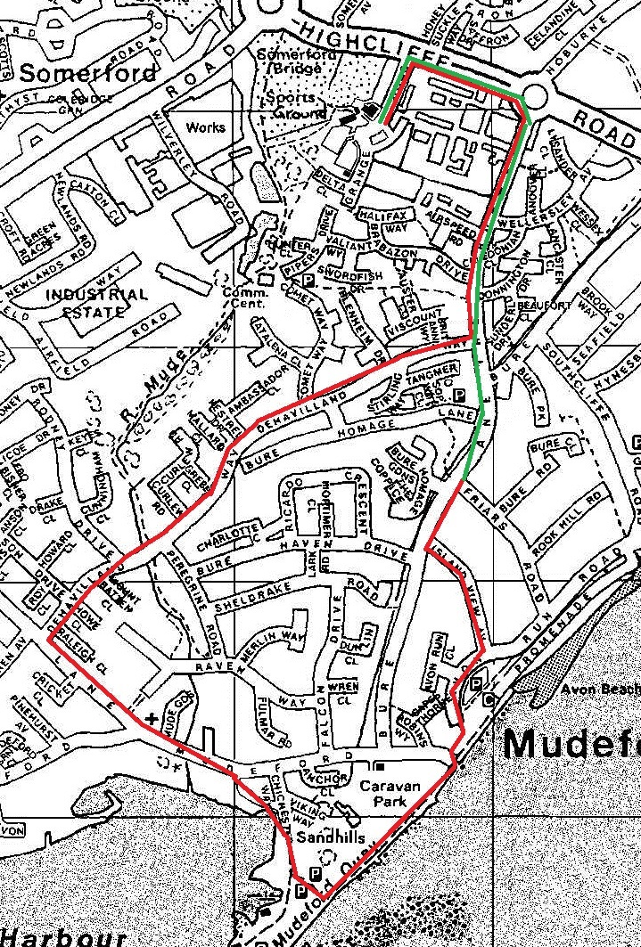

The “normal” direction is anticlockwise starting with the red line and finishing with green.
This is run in October, December, January and March.

The “reverse” direction is clockwise starting with the green line and finishing with red. This is run in November and February.

Monthly Race, Normal Winter Route:
1. Head north on Grange Rd and at the dual-carriageway turn right.
2. At the roundabout turn right onto The Runway.
3. Take the 3rd right into De Havilland Way
4. At the end turn left onto Mudeford Lane
5. At the end turn left onto Mudeford and cross when it is safe to do so
6. Cross the road by the shops, and fork right down the road with no-entry signs
7. Follow the road to the main car park (do not use the footpath to the playground on the left near the seafront) and turn left past the barrier along the prom
8. When you go through the next barrier, turn left across the car park entrance and turn right up the footpath immediately after the car park entrance
9. Turn left to skirt the sunken car-park and turn left into Island View Avenue
10. At the end turn right onto The Runway
11. At the roundabout turn left onto Highcliffe Road (dual carriageway)
12. Turn left into Grange Road and finish.

Monthly Race, Reverse Winter Route:
1. Head north on Grange Rd and at the dual-carriageway turn right.
2. At the roundabout turn right onto The Runway.
3. Take the 5th left into Island View Avenue
4. At the end turn right and skirt the sunken car-park, then drop down the footpath to the promenade and head west towards Mudeford Quay.
5. At the car-park turn right (do not use the footpath to the playground on the right near the seafront), instead follow the road to exit Mudeford Quay.
6. After the bridge take the left fork and at the end turn left onto Mudeford, then 3rd right onto Mudeford Lane.
7. Take the 1st right onto De Havilland Way and follow it to the end.
8. Turn left onto The Runway.
9. At the roundabout turn left onto Highcliffe Road (dual carriageway)
10. Turn left into Grange Road and finish.

